**Lab report no 8**



**Fall 2022**

# Control System Lab

**Submitted By**

**Name Registration No**

# Muhammad Ali 19pwcse1801

Section: **A**

**Date**: 27,12,22

**Submitted to: Dr Muniba Ashfaq**

Department of Computer Systems Engineering

University of Engineering and Technology, Peshawar

**Objectives: -**

* To understand Residue of transfer function
* To learn Frequency Domain modelling

**OBJECTIVES:**

**TASK 01: -**

# F(s)=2/(s+1)(s+2)^2

%Task one num=2; den=[-1 -2 -2]; po=poly(den);

[r,b,k] = residue(num,po)

**OUTPUT: -**

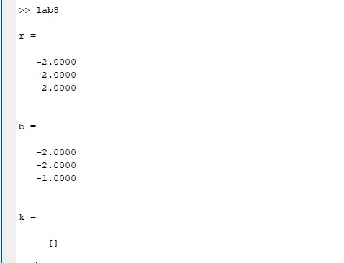

**TASK 02: -**

1. **F(s)=3/s(s^2+2s + 5)**
2. **%Task 2**
3. **num2 = 3;**
4. **root2 = [ 1 2 5];**
5. **d=roots(root2)**
6. **p2=[0,d(1) , d(2)]**
7. **den2=poly(p2)**
8. **[r,b,k]=residue(num2,den2)**

**OUTPUT: -**

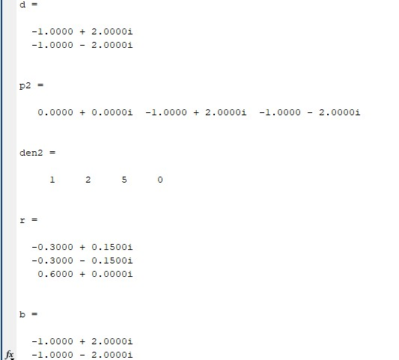

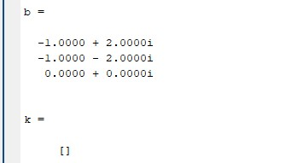

**TASK 03:**

3) **F(s)=5/(s+1)(s+2)(s+3)**

%Task 3 num3 = 5; root3 = [ -1 -2 -5]; den3=poly(root3)

[r,b,k]=residue(num3,den3)

**OUTPUT:**

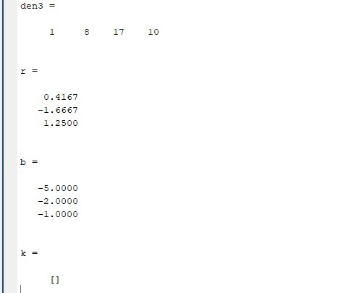

**TASK 04: -**

**Find inverse laplace transform of the following using symbolic toolbox.**

**F(s)=1/s(s+1)**

%task 4 syms s C=1/(s+(s+2)); C = ilaplace(C) pretty(C)

**OUTPUT: -**

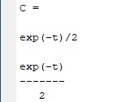

**TASK 05: -**

Find inverse laplace transform of Question one ,two, and three

%Task 5

%inver laplace transform question one , two,and three

C=2/(s+1)*(s+2)^2; C = ilaplace(C) pretty(C)

%Task 6

C=3/s*(s^2+2*s + 5); C = ilaplace(C) pretty(C)

%task 7

C=5/(s+1)*(s+2)*(s + 3); C = ilaplace(C) pretty(C)

**OUTPUT: -**

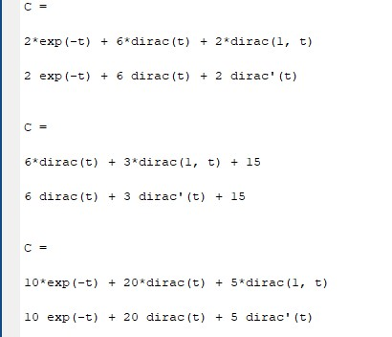

**TASK 06: -**

Use matlab and symbolic toolbox to find the value of .

**(2s+2)I1(s) -(s2+1)I2(s) -I3(s) = V(s)**

**-(2s+1)I1(s) +(9s+1)I2(s) -4sI3(s) = 0**

**-I1(s) -4sI2(s) +(4s+1 +1/s)I3(s) = 0**

%task 8 last task. syms s I1 I2 I3 V

A = [(2*s + 2)*(-1 * (2*s + 1))*(-1);

(-1*(2*s + 2))*(9*s + 1)*(-4 *s);

-1*(-4*s)*((4*s) +1 +1/s)];

B=[I1;I2;I3];

C=[V; 0; 0]; B=inv(A)*C;

pretty(B)